

NAME: EUGINE KIPCHIRCHIR
ADM NO: BSCCS/2024/53845
COURSE: BACHELOR OF SCIENCE IN INFORMATION TECHNOLOGY
DEPARTMENT: COMPUTING AND INFORMATICS
UNIT:ADVANCE CRYPTOGRAPHY
UNIT CODE:BIT4138
LECTURER : MICHAEL NYORO
SUBMISSION DATE: 8/6/2026
GITHUB LINK: https://github.com/smooth254-arch/Adv-Cryptography-work.git

TABLE OF CONTENT
WEEK 1: CRYPTOGRAPHY ENVIRONMENT SETUP 3
INSTALLATION AND CONFIGURATION OF CRYPTOGRAPHY DEVELOPMENT ENVIRONMENT 3
Fig 1: Installation of Python and VS Code 3
Fig 2: Installation of Cryptography Libraries 4
Step 3: OpenSSL Test 4
Step 4: Create a Simple Encryption Script 4
Step 5: GitHub Repository Initialization 5
MY REFLECTION 5
WEEK 2: CLASSICAL CRYPTOGRAPHY AND CIPHER DESIGN 6
IMPLEMENTATION OF CLASSICAL ENCRYPTION ALGORITHMS 6
Fig 1: Caesar Cipher Implementation 6
Fig 2: Vigenère Cipher Encryption Process 6
Fig 3: Encryption and Decryption Output 7
Fig 4: User Input Validation Interface 7
Fig 5: Cipher Testing Results 8
MY REFLECTION 8
WEEK 3: STREAM CIPHERS & RANDOMNESS TESTING 9
IMPLEMENTATION OF STREAM CIPHER SYSTEMS AND RANDOM SEQUENCE ANALYSIS 9
Fig1: LFSR Generator Implementation 9
Fig2: Pseudorandom Sequence Output 9
Fig3: Statistical Randomness Testing 10
Fig4: RC4 Stream Cipher Simulation 10
Fig5: Encryption Performance Results 11
MY REFLECTION 11
WEEK 4: BLOCK CIPHER DESIGN AND AES 11
ADVANCED ENCRYPTION STANDARD (AES) AND BLOCK CIPHER OPERATIONS 11
Fig 1: AES Encryption Script 11
Fig 2: Key Generation Process 11
Fig 3: File Encryption Demonstration 11
Fig 4: Decryption Results 11
Fig 5: AES Performance Testing 11
MY REFLECTION 11
WEEK 5: PUBLIC KEY CRYPTOGRAPHY (RSA) 12
Implementation of RSA Encryption and Key Management 12
Fig 1: RSA Key Pair Generation 12
Fig 2: Public Key Encryption Process 12
Fig 3: Private Key Decryption Results 12
Fig 4: Secure Message Transmission 12
Fig 5: RSA Testing and Validation 12
MY REFLECTION 12

WEEK 1: CRYPTOGRAPHY ENVIRONMENT SETUP

INSTALLATION AND CONFIGURATION OF CRYPTOGRAPHY DEVELOPMENT ENVIRONMENT

Fig 1: Installation of Python and VS Code
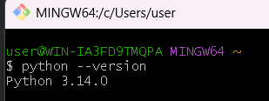
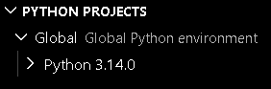

Fig 2: Installation of Cryptography Libraries
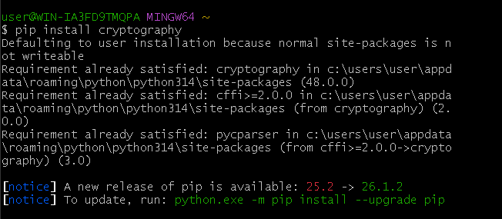
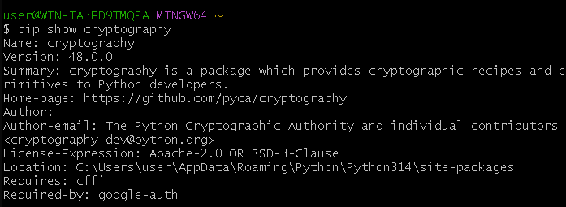

Step 3: OpenSSL Test
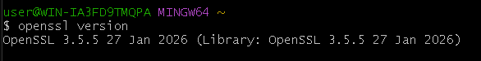

Step 4: Create a Simple Encryption Script
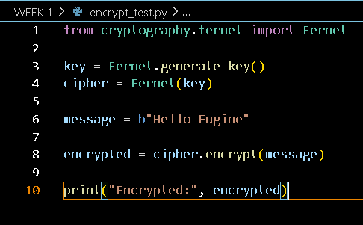
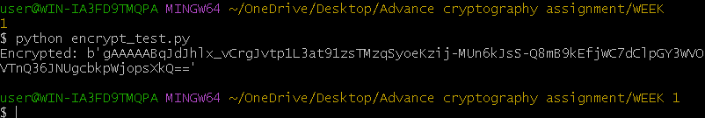

Step 5: GitHub Repository Initialization
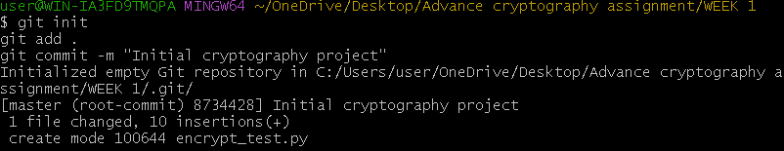
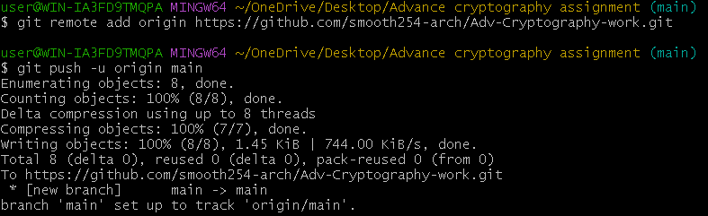

MY REFLECTION
I configured the cryptography development environment by installing Python, VS Code, OpenSSL and the Cryptography library. I successfully executed an encryption script and initialized a Git repository. The activities improved my understanding of secure development tools and project version control.

WEEK 2: CLASSICAL CRYPTOGRAPHY AND CIPHER DESIGN

IMPLEMENTATION OF CLASSICAL ENCRYPTION ALGORITHMS

Fig 1: Caesar Cipher Implementation
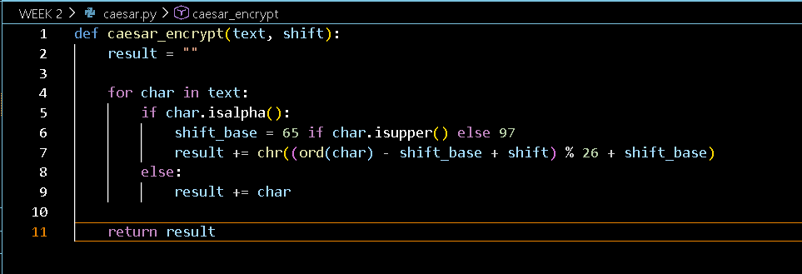

Fig 2: Vigenère Cipher Encryption Process
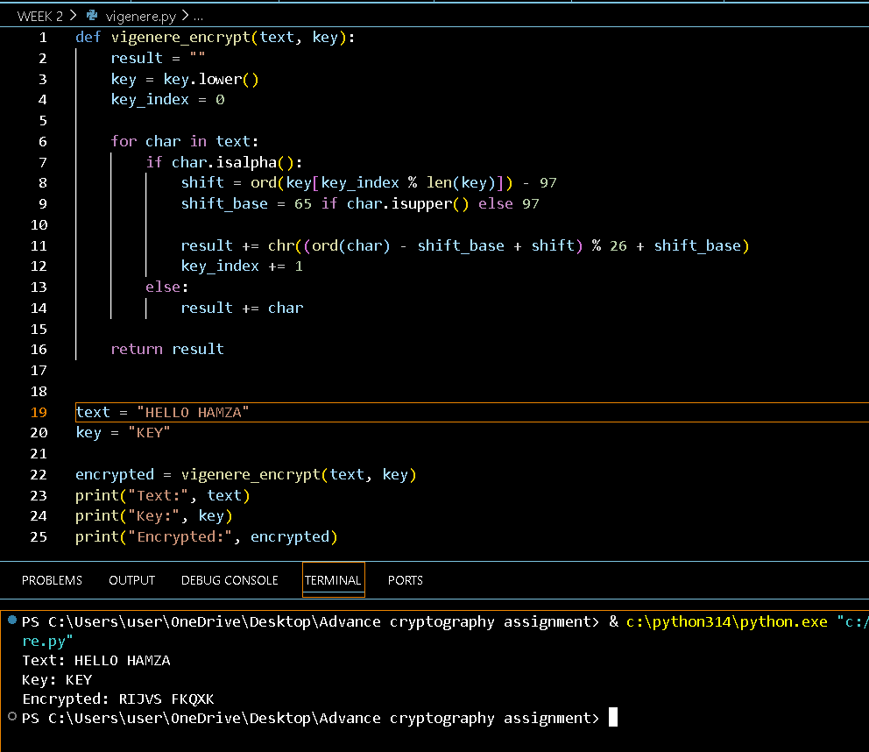

Fig 3: Encryption and Decryption Output
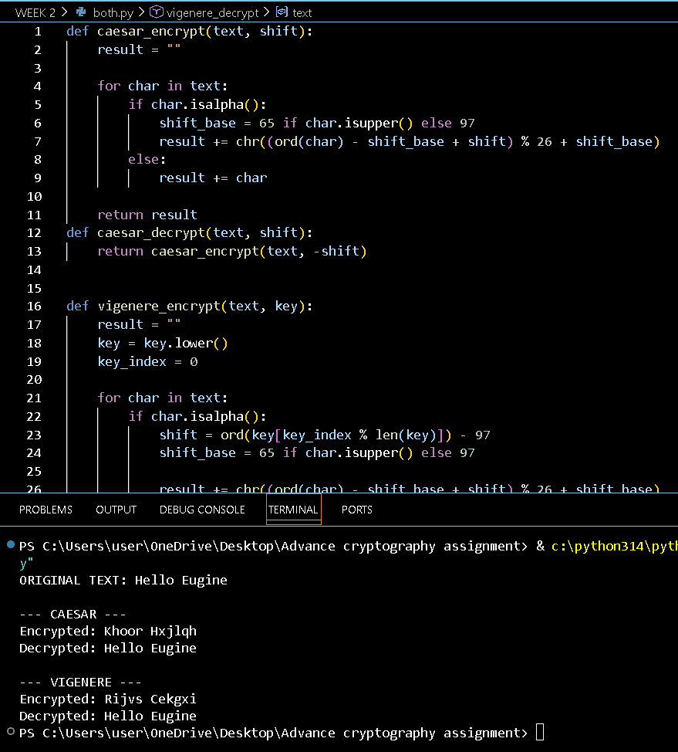

Fig 4: User Input Validation Interface
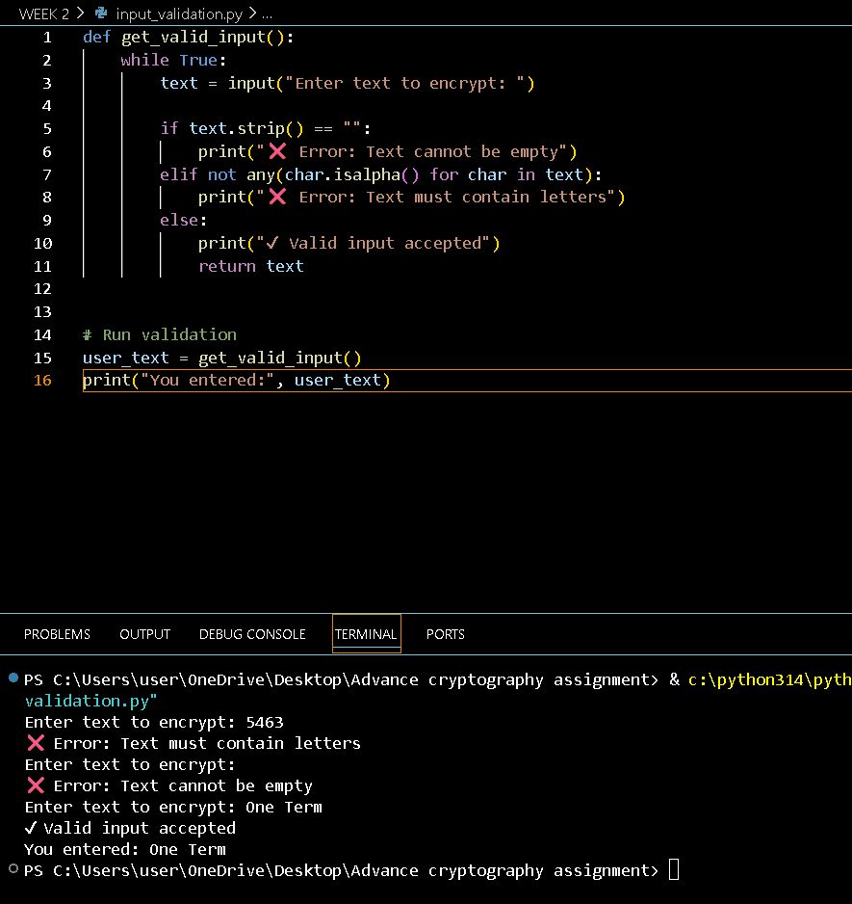

Fig 5: Cipher Testing Results


MY REFLECTION
I have learnt that the use of encryption algorithms entails substituting data with cipher text. Encryption keys decide how that happens and they make it possible to reverse the operation. The three major phases involved include inputs, encryption and decryption phases. Both the Caesar cipher and the Vigenere cipher are susceptible to brute force attack.

WEEK 3: STREAM CIPHERS & RANDOMNESS TESTING

IMPLEMENTATION OF STREAM CIPHER SYSTEMS AND RANDOM SEQUENCE ANALYSIS

Fig1: LFSR Generator Implementation
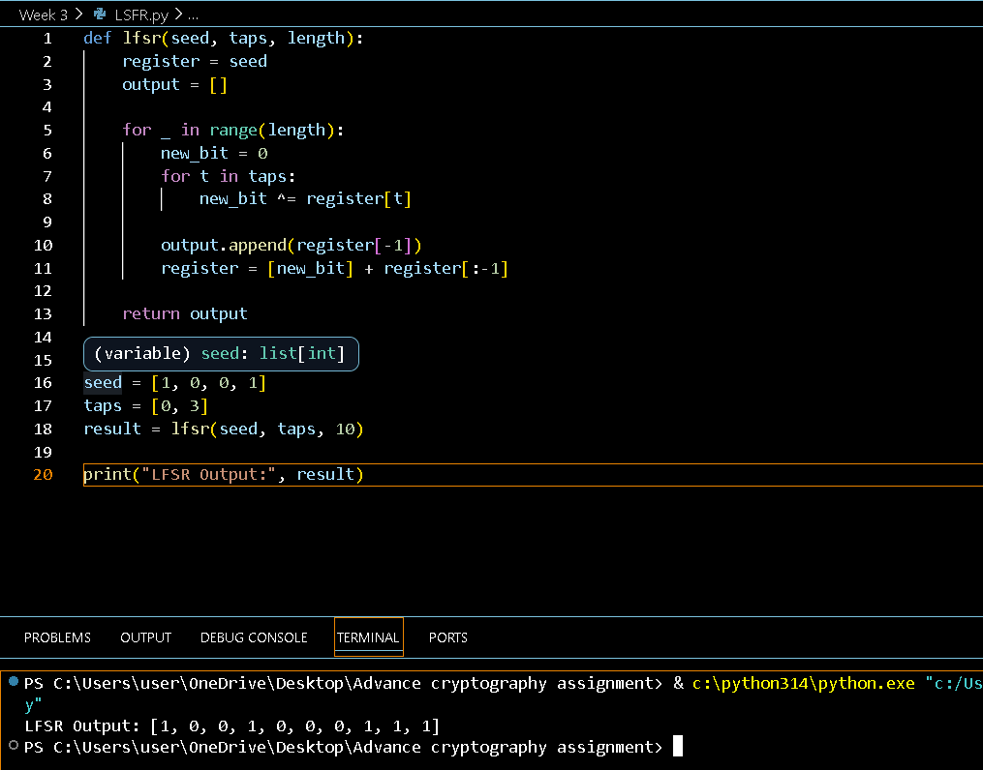

Fig2: Pseudorandom Sequence Output
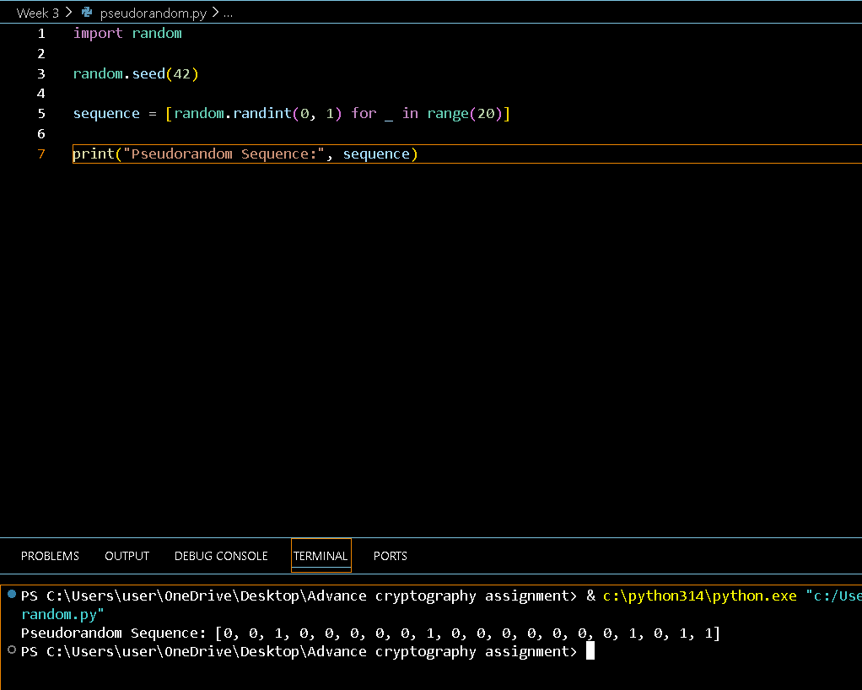

Fig3: Statistical Randomness Testing
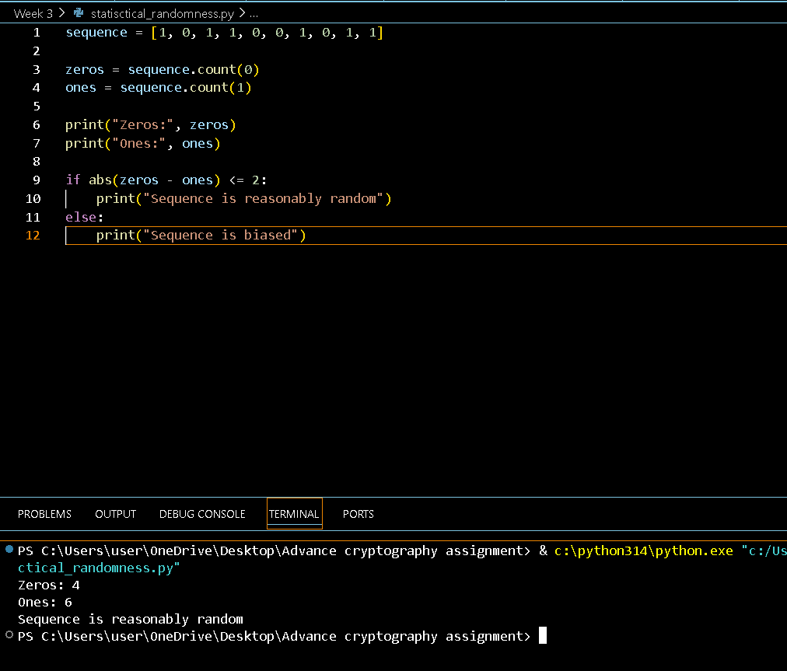

Fig4: RC4 Stream Cipher Simulation
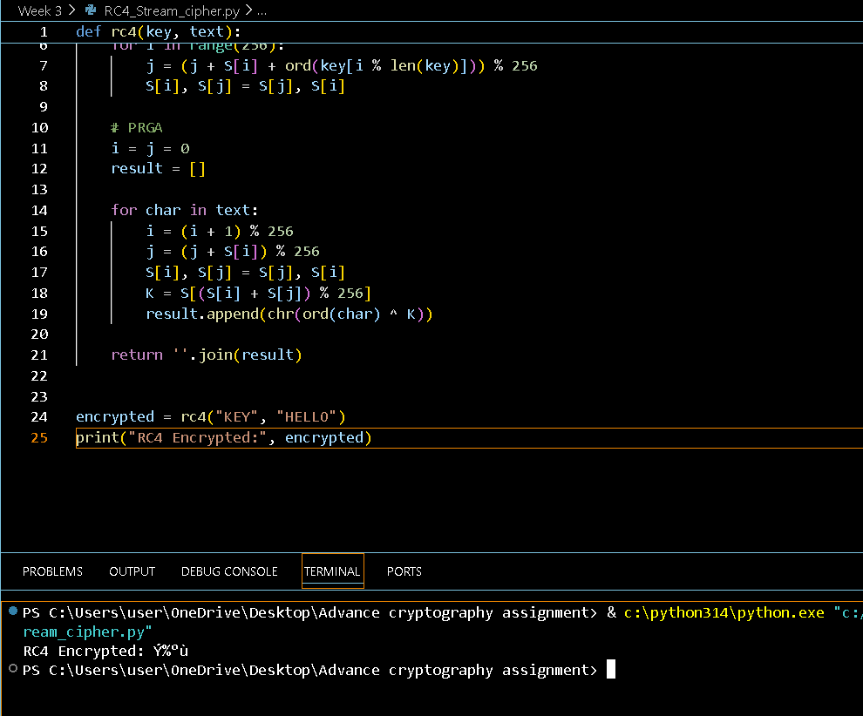

Fig5: Encryption Performance Results
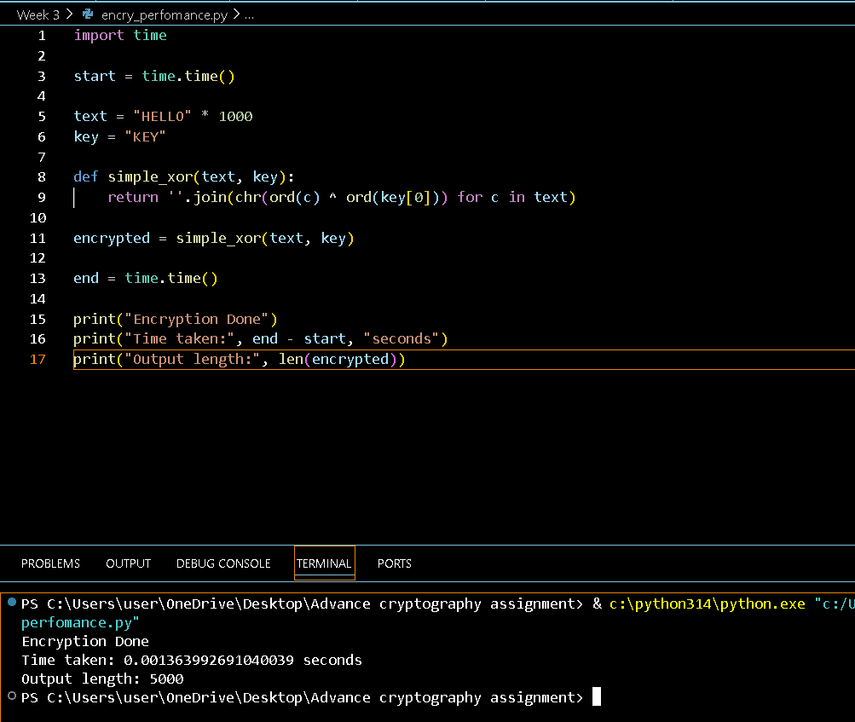

MY REFLECTION
The feature of randomness ensures unpredictability in cryptography. In stream ciphers, keystreams are produced by which data is encrypted on a bit-by-bit basis. LFSR and RC4 show pseudorandom generation and encryption. Tests for randomness ensure its quality. It is important for security because it prevents attacks.

WEEK 4: BLOCK CIPHER DESIGN AND AES

ADVANCED ENCRYPTION STANDARD (AES) AND BLOCK CIPHER OPERATIONS

Fig 1: AES Encryption Script
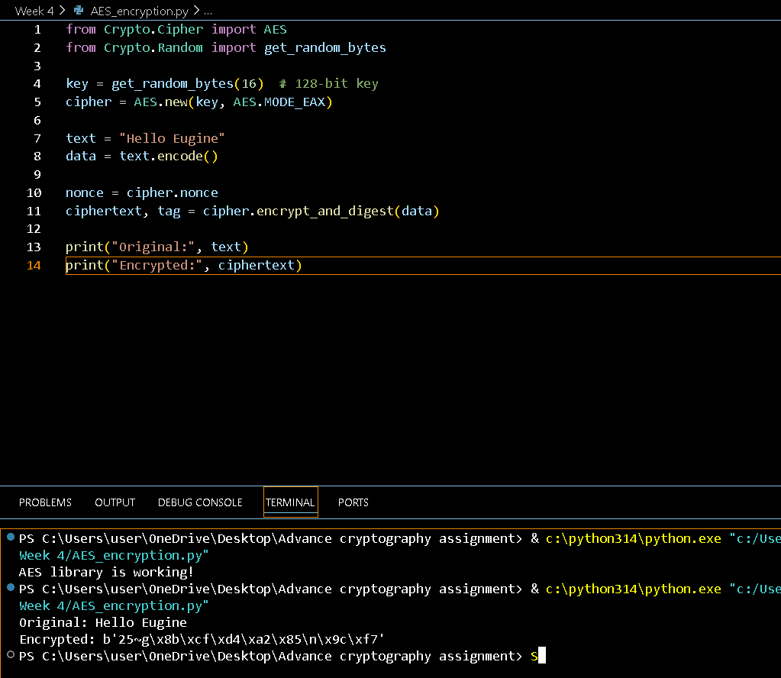

Fig 2: Key Generation Process
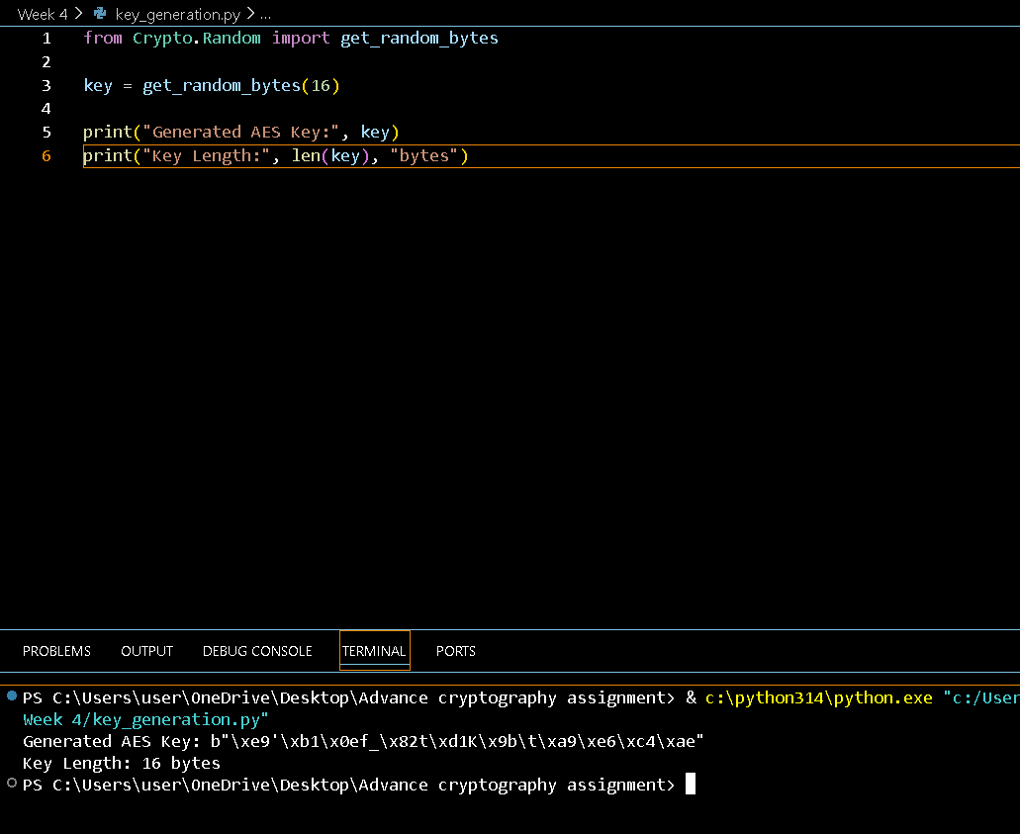

Fig 3: File Encryption Demonstration
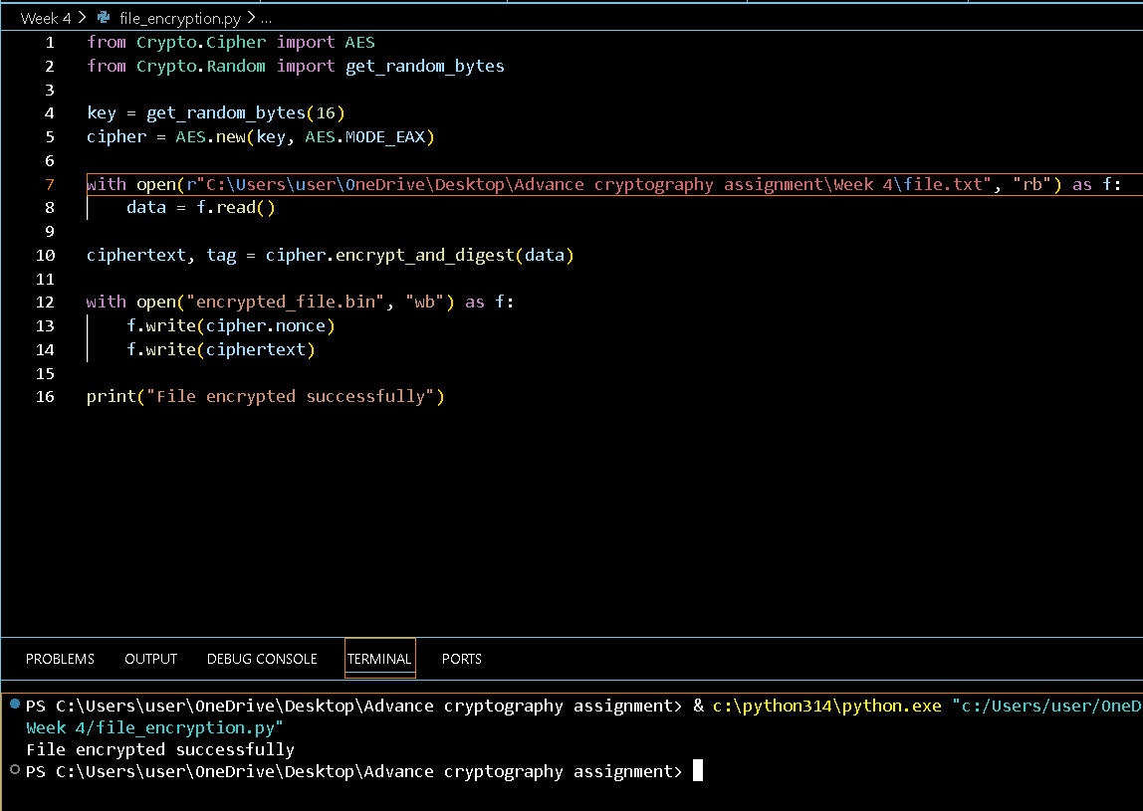

Fig 4: Decryption Results
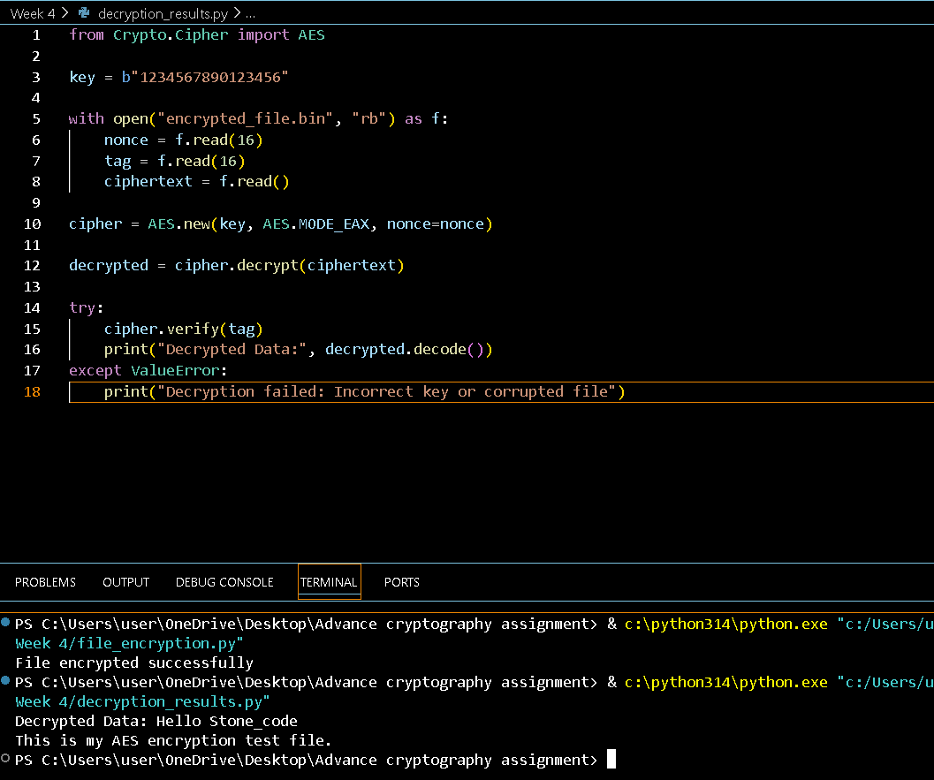

Fig 5: AES Performance Testing
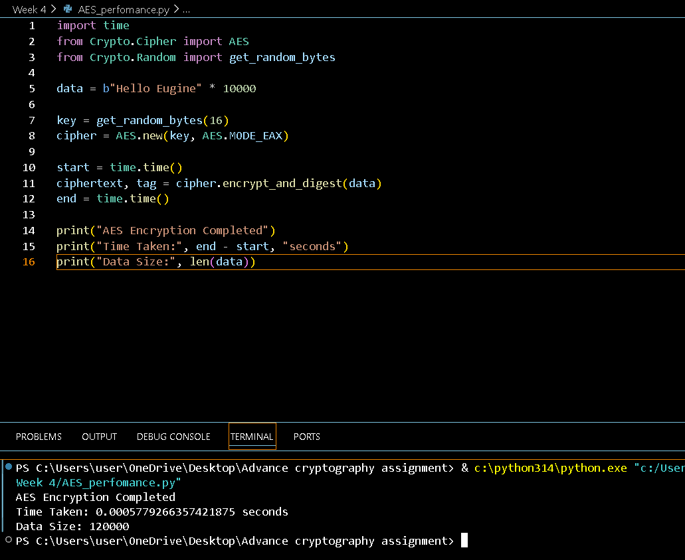

MY REFLECTION
AES uses block cipher processing to provide strong and secure encryption algorithms that use symmetric keys. AES comprises the process of key generation, encryption and decryption. The security of the key is of utmost importance since it secures the information. Some of the problems that came during implementation were with files and key consistency.

WEEK 5: PUBLIC KEY CRYPTOGRAPHY (RSA)

Implementation of RSA Encryption and Key Management

Fig 1: RSA Key Pair Generation
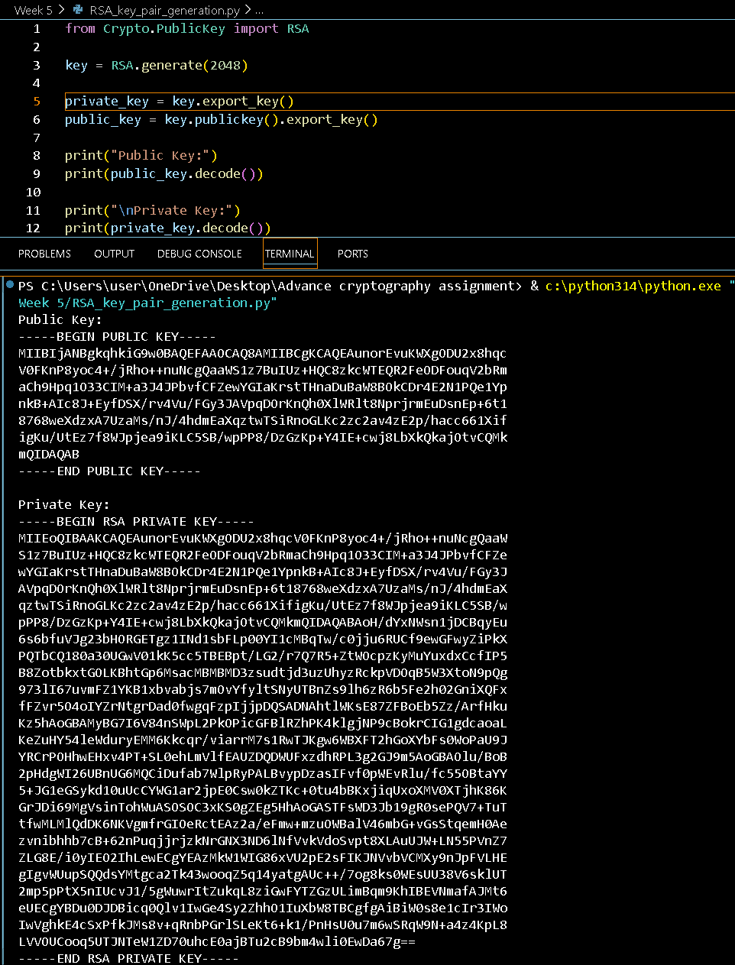

Fig 2: Public Key Encryption Process
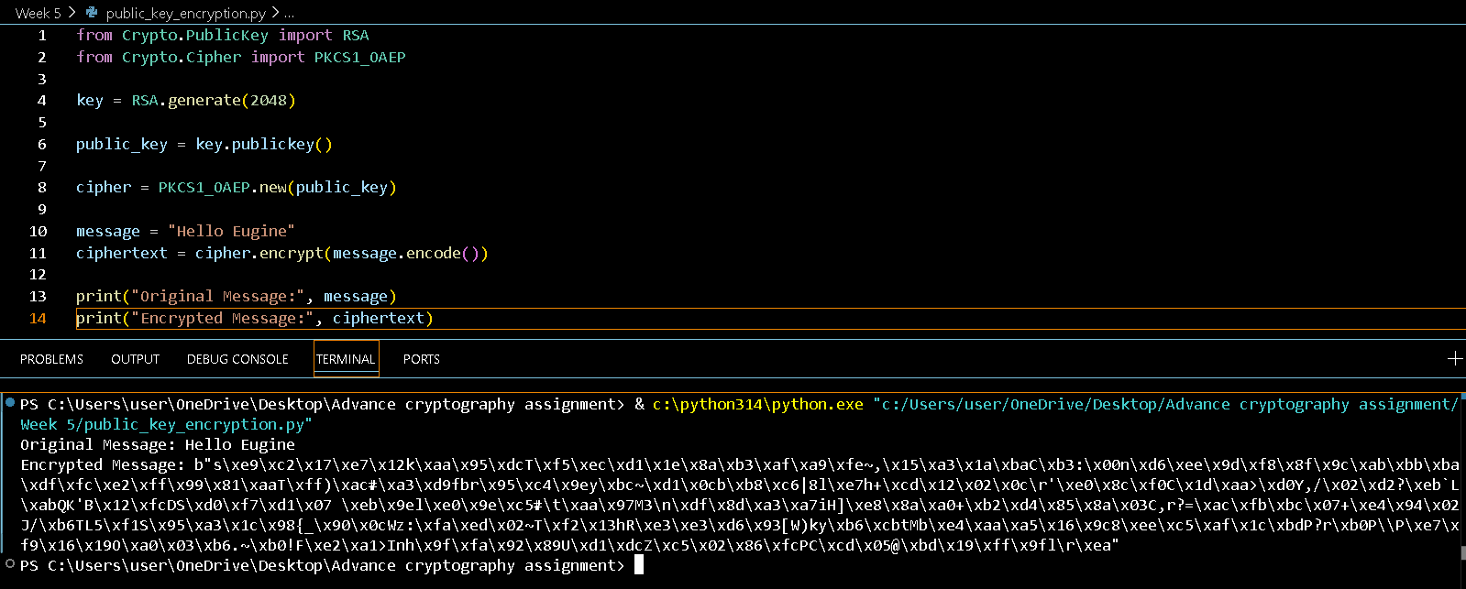

Fig 3: Private Key Decryption Results
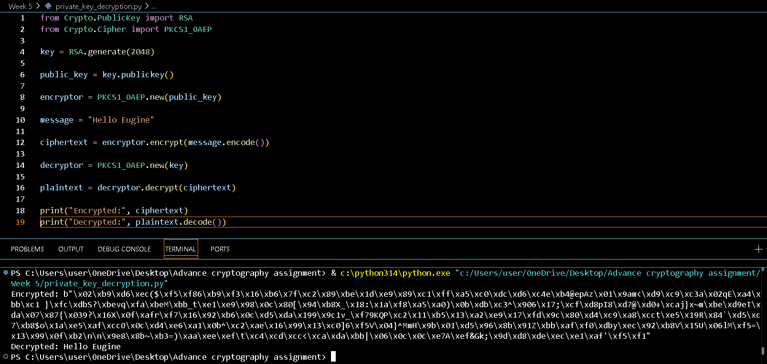

Fig 4: Secure Message Transmission
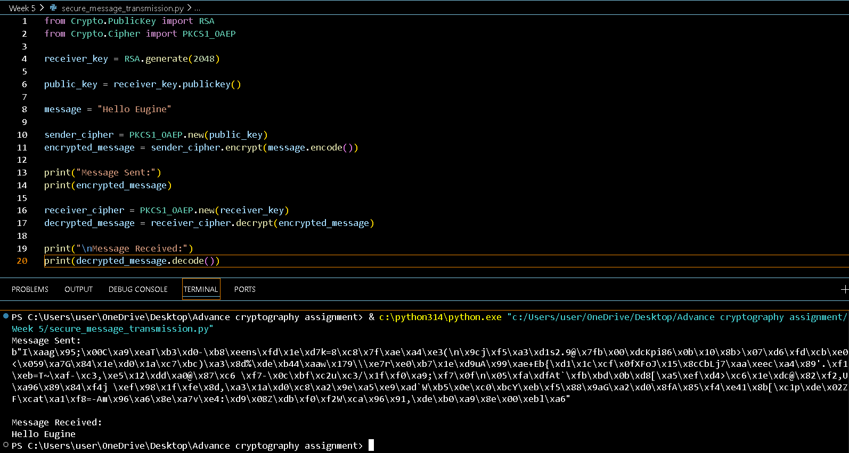

Fig 5: RSA Testing and Validation
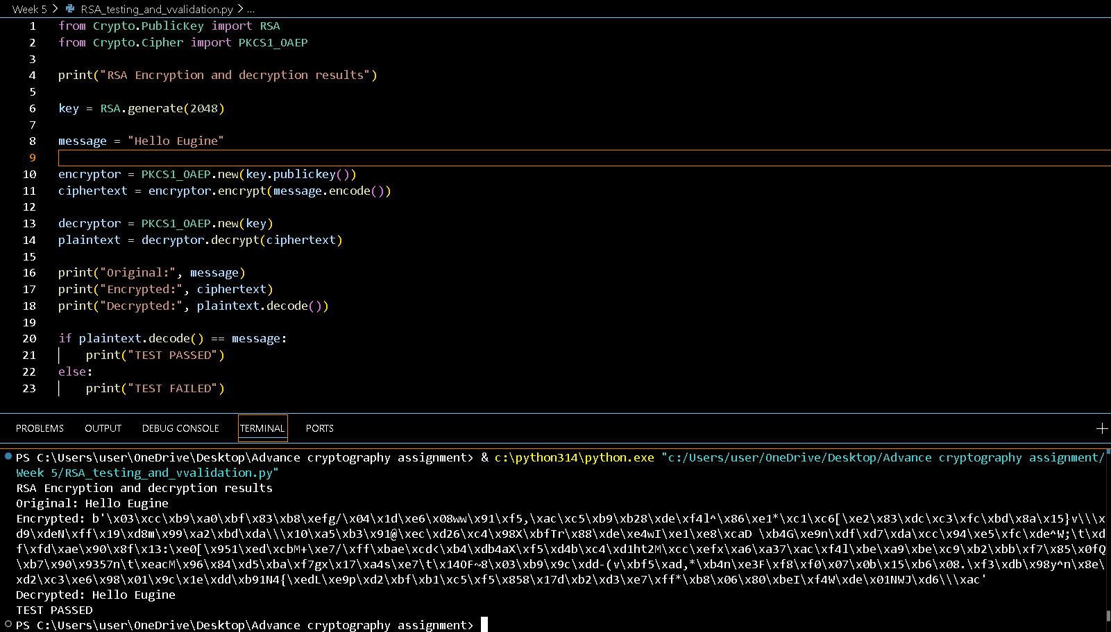

MY REFLECTION
RSA utilizes asymmetric cryptography rather than symmetric cryptography that utilizes only one key for both encryption and decryption. The public key is used for encrypting messages and the private key is used for decrypting messages. RSA increases security because of the separation of the functions of keys.

